The home is heated by a dragon
Stiebel Eltron heat pump with customised design
They were feared and spread terror and chaos. Many a courageous warrior rode out in medieval times to slaughter them. But dragons are far more than just fire-breathing beasts. Throughout the world these fabled beings have played a role in popular myths – frequently a positive one. For instance, dragons were used as ornamentation on the Vikings’ boats, weapons and churches. In China, the dragon is also a symbol for the spring, water and rain. And the song “Puff the Magic Dragon” has always been a strong favourite with children especially. “Whenever I see our dragon, it always puts me in a good mood”, says Andreas Hagenbach from Ilvesheim near Mannheim. He had his Stiebel Eltron air-to-water heat pump decorated with the mythical figure by airbrush artist Lothar Bohn. Since then, it has stood out a mile from the neighbours’ heat generators – for in front of every house in Maifischweg you will see an external unit belonging to the environmentally friendly heating system that usually tends to be quite unobtrusive.
“We want our heat pump to look different to those of our neighbours”, the Hagenbach family had said from the outset. Whether intentionally or not – they were guided by Chinese mythology in choosing the design. Dragons over there are considered to be creatures of the air, heat and happiness. These three aspects are also characteristic of air source heat pumps: they extract energy from the air outside and ensure an efficient supply of heat and hot water – making the occupants of the home very happy. Running on electricity, Stiebel Eltron’s modern appliances obtain up to four parts heating energy from one part electricity. This is how they keep energy costs down and help to protect the environment. So the dragon on the Hagenbachs’ heat pump could really look a bit more cheerful about things.

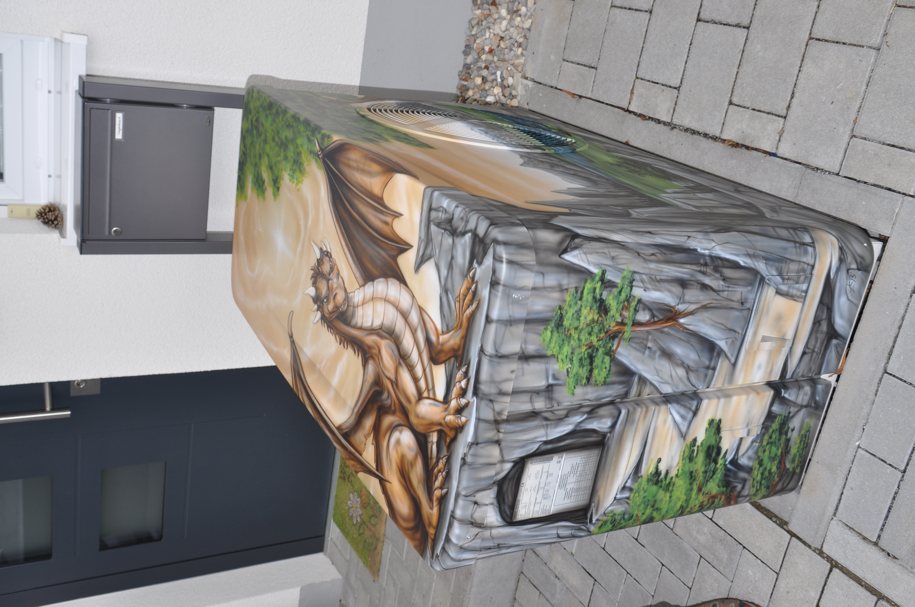
The home is heated by a dragon

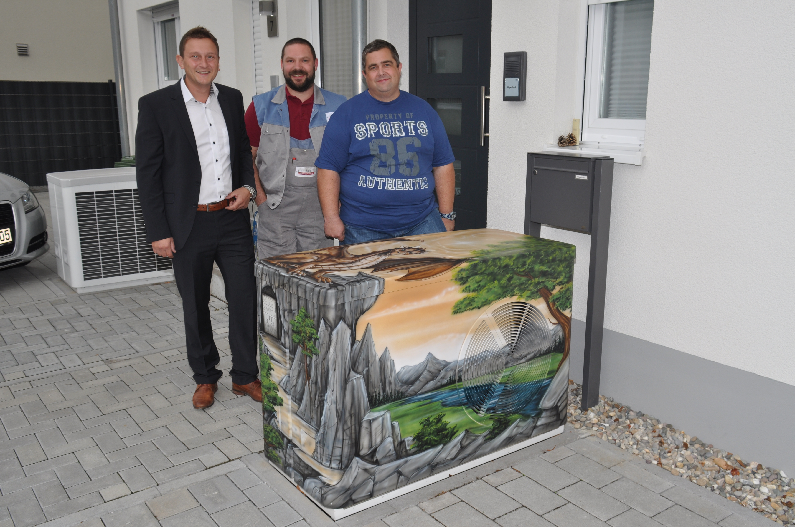Three people who enjoy the more attractive look of their heat pump: Andreas Hagenbach, Andreas Krupp, from Felske Heizung/Sanitär customer service and Oliver Rink from Stiebel Eltron (from the right)
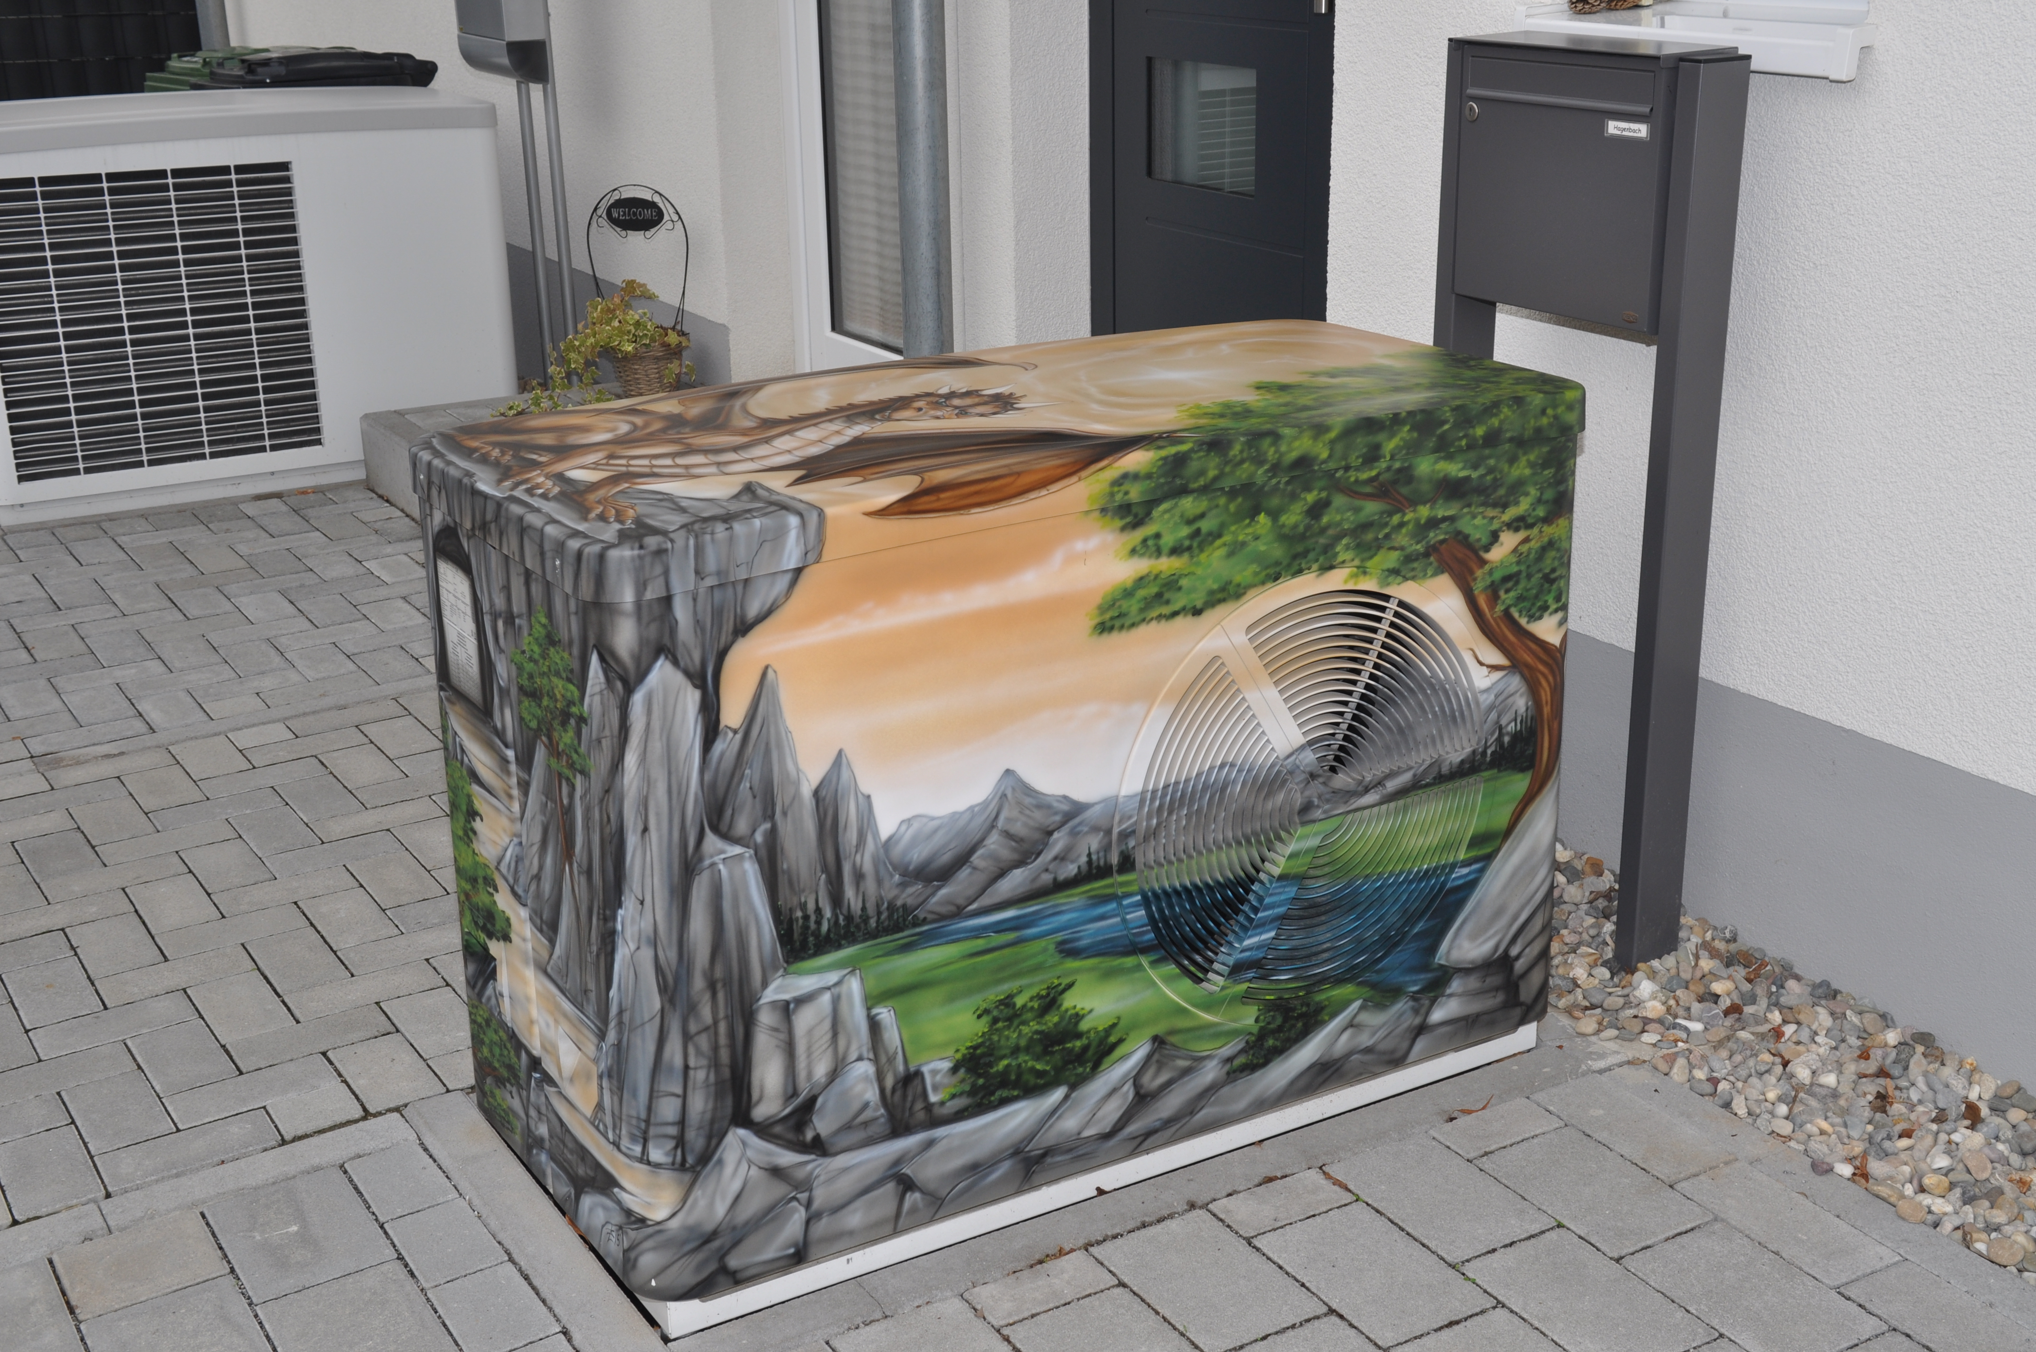Two homes, Stiebel Eltron twice over: once in a customised design, once in the original

