Martin Repschlaeger new member of the Stiebel Eltron Management Board

Detlef Neuhaus leaves the board

The Supervisory Board of the Stiebel Eltron Group has appointed Martin Repschlaeger as a new member of the Management Board. At the same time, Detlef Neuhaus' request to terminate his
contract as Managing Director was granted.

Detlef Neuhaus was appointed Managing Director of the Stiebel Eltron Group on January 1, 2025.
With his extensive operational restructuring experience, he supported Stiebel Eltron in the cost-cutting programs that became necessary as a result of the sales collapse in 2024. He has accompanied the adjustment of the corporate strategy and the securing of corporate financing. After these tasks were completed in the first half of 2025, Detlef Neuhaus asked the Supervisory Board to terminate his contract for personal reasons with effect from 15 July 2025. The Supervisory Board regrets and respects Detlef Neuhaus' decision. The Supervisory Board, shareholders and the Stiebel Eltron management would like to thank Detlef Neuhaus for his contribution as Managing Director during a difficult phase for the company and for his previous five years on the Supervisory Board and wish him all the best for his future. As Managing Director, Detlef Neuhaus has provided important impetus for
energy management and the systematic further development of sales as well as for addressing
new customer groups.

At the same time, the Supervisory Board has appointed Martin Repschlaeger as Managing Director. The 58-year-old has been with Stiebel Eltron since 2002 in various roles in the finance department, most recently as Head of Finance with responsibility for accounting, controlling and taxes. In addition to the CEO, Dr. Kai Schiefelbein, and the CSO/CMO, Heinz-Werner Schmidt, Martin Repschlaeger will act as Managing Director Finance (CFO).

About STIEBEL ELTRON
Stiebel Eltron, founded in 1924, is one of the leading companies in the renewable energy, heating and building technology market with an annual turnover of around one billion euros.
As an innovation-driven family business, Stiebel Eltron pursues a clear line in the production and development of products - for environmentally friendly, efficient and comfortable domestic technology. With around 5,000 employees worldwide, the company consistently relies on its own expertise from product development to production. The result is efficient and innovative solutions for hot water, heating, ventilation and cooling. Stiebel Eltron produces at its main site in Holzminden in Lower Saxony, in Höxter (NRW), in Hameln (NDS), in Freudenberg (NRW) and in Eschwege (Hessen) as well as at five other sites abroad (Arvika/Sweden, Tianjin/China, Ayutthaya/Thailand, Poprad/Slovakia, West Hatfield, Massachusetts/USA).
Picture 1:
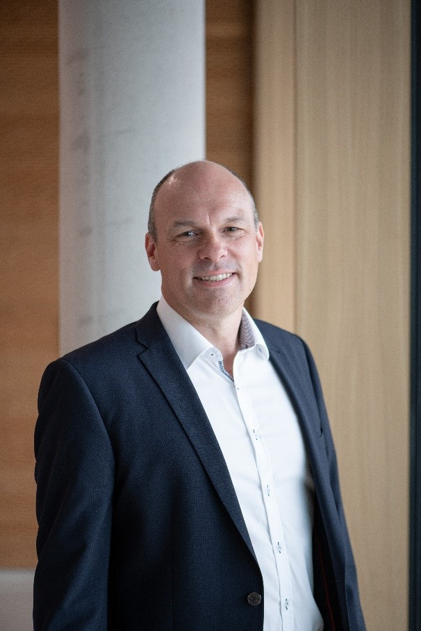 |  | Martin Repschlaeger joins the Chief Executive Officer (CEO), Dr. Kai Schiefelbein, and the Chief Sales and Marketing Officer (CSO/CMO), Heinz-Werner Schmidt, as Chief Financial Officer (CFO) of the Stiebel Eltron Group.

