Stiebel Eltron at the ISH 2023: New Products and Simple System Solutions

Focus on Heat Pumps, Ventilation and Domestic Hot Water Preparation
"Anyone who is interested in the highlight topics of the industry is in exactly the right place at our stand in Hall 12: at the ISH in Frankfurt, we will not only be presenting new products from the areas of heat pumps, ventilation and domestic hot water preparation; but also complete system solutions, especially when it comes to heat pumps. Because the challenges are huge: the heat turnaround is happening now! And with our decades of expertise, our products and our services, we are the perfect partner for all those involved in construction." When Frank Jahns, Managing Director of Stiebel Eltron's German sales company, talks about the world's leading trade fair for the sanitation and heating industry, you can clearly see his anticipation. "As far as I'm concerned, it could start right away! We are eager to convince the trade, planners and architects, the real estate industry and all other interested parties of our solutions!"

Three zones await guests at the heating expert's stand: "Heat pump and ventilation in new buildings", "Decarbonisation in the real estate industry" and "Heating modernisation with heat pump". Under the motto "WP easy - heat pump, easier than ever!" Stiebel Eltron will be presenting, for example, four standardised heat pump sets each for use in new and existing buildings. The pre-configured system solutions are suitable for around 80 percent of applications in detached and semi-detached houses and can be quickly and efficiently installed in series thanks to recurring system concepts and suitable pre-parameterisation. "This saves the trade an immense amount of time - once during planning and design, then again during the installation itself," says Jahns.

In addition to the heat pump sets, the company will be showing numerous new products, including a new brine-to-water heat pump, the successor to the classic small storage unit SNU and a new home station as a further solution for decarbonisation in multi-storey residential buildings. In addition, the new energy management software will be presented, which networks the heat pump and photovoltaic system and ensures the maximisation of self-consumption by optimally controlling the energy flows.

In addition, Stiebel Eltron will provide information on its multi-level partner program at the trade fair stand. The concept offers four development levels: Specialist tradesmen can develop from heat pump starter to specialist partner and premium specialist partner to heat pump service point. The company not only provides the “heat pump driving licence”, but also comprehensive sales support - for example, through accompanied commissioning and warranty checks as well as marketing support.
About STIEBEL ELTRON
STIEBEL ELTRON is an internationally operating Group and is among the global market and technology leaders in the fields of building services and renewable energies. Since 1924, technical performance, quality, innovation, reliability and customer-oriented service have been defining factors in our success. With four national and four international production facilities, 26 sales organisations around the world, plus partners and agencies in 120 countries, STIEBEL ELTRON has a global presence. The annual turnover amounts to more than one billion Euros. More than 50 per cent of the turnover is generated abroad.
In 1924 in Berlin the company founder Dr Theodor Stiebel started realising his vision of developing and manufacturing products with low energy consumption, greater safety and more comfort. This objective still applies to the company today.

Picture 1:
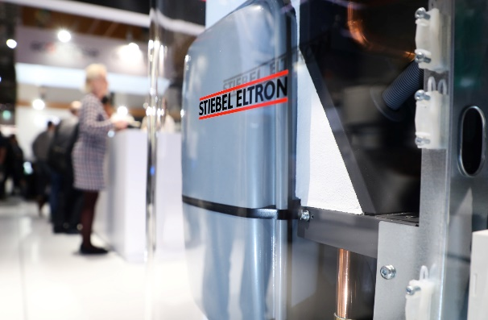 |  | Stiebel Eltron at the ISH 2023

If required, please contact the following person:
STIEBEL ELTRON:
Henning Schulz
Leiter Unternehmenskommunikation
Tel.: +49 (0) 55 31 / 70 29 56 85
henning.schulz@stiebel-eltron.de

