Architects' Darling Award

Stiebel Eltron is once again an "architect's favorite" in 2022
This year's Architects' Darling once again honored the most popular brands in the building industry. Stiebel Eltron won the "Oscar of the building industry" in the category "air conditioning / ventilation / home ventilation" – already for the fifth time. "A great success for our commitment in the field of domestic ventilation", says Head of Corporate Communication Henning Schulz. "This proves that our brand is well established among architects and planners."

Stiebel Eltron can look back on a long history of success in the field of building technology. Started almost 100 years ago as a hot water expert, the company is now a pioneer when it comes to sustainable heating system technology in buildings. In addition to almost 50 years of heat pump expertise, Stiebel Eltron has been developing and producing products for controlled ventilation for over 20 years. Whether in commercial buildings, as centralized residential ventilation or as a decentralized ventilation solution for refurbishment: The German-based company offers the right ventilation system for every requirement. And this is also honored by architects and planners with the company's "Architects' Darling" award in the category "Air Conditioning / Ventilation / Residential Ventilation".

Architects Darling
Heinze GmbH presented the "Architects' Darling" award for the first time in 2011. The opinions of architects and planners throughout Germany are decisive for the award. This year, a total of 1,874 of them took part in Germany's largest multimedia industry survey. In turn, 171 manufacturers, many of whom were present at the festive awards ceremony on 9 November 2022, took part in their judgement. A total of 24 brand awards were honored this year.
About STIEBEL ELTRON
STIEBEL ELTRON is an internationally operating Group and is among the global market and technology leaders in the fields of building services and renewable energies. Since 1924, technical performance, quality, innovation, reliability and customer-oriented service have been defining factors in our success. With four national and four international production facilities, 26 sales organisations around the world, plus partners and agencies in 120 countries, STIEBEL ELTRON has a global presence. The annual turnover amounts to more than 800 million Euros. More than 50 per cent of the turnover is generated abroad.
In 1924 in Berlin the company founder Dr Theodor Stiebel started realising his vision of developing and manufacturing products with low energy consumption, greater safety and more comfort. This objective still applies to the company today.

Picture 1:
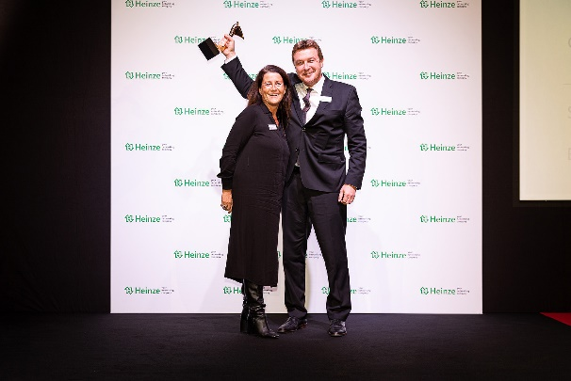 |  | Stiebel Eltron is once again awarded with the Architects' Darling. Fátima Wille, Marketing Manager Germany, and Henning Schulz, Head of Corporate Communication, received the award at a gala.  ©Heinze GmbH, Marcus Jacobs

If required, please contact the following person:
STIEBEL ELTRON:
Henning Schulz
Head of Corporate Communication
Tel.: +49 (0) 55 31 / 70 29 56 85
henning.schulz@stiebel-eltron.de

