STIEBEL ELTRON is a "Superbrand”

Award for Outstanding Brand Management
Heat pump manufacturer STIEBEL ELTRON has once again been rewarded as a "Superbrand". Fátima Wille, Marketing Manager Germany, and Henning Schulz, Head of Corporate Communication, received the award at a gala in the historic Herzog Friedrich August Hall of the Wiesbaden Casino Society. "We are very proud to receive the award again. This is an acknowledgement of our continuous work on an authentic, sustainable and innovative brand," says Fátima Wille. STIEBEL ELTRON is in good company as a "Superbrand": Alongside other well-known German brands, athletics star Malaika Mihambo was also honoured as a Superbrand personality in Wiesbaden, Germany.

STIEBEL ELTRON has been driving the energy transition with full conviction for years. With products for heating and cooling as well as ventilation and hot water, the globally successful company provides a "home to be comfortable" in numerous countries. "In the heating sector, we have for decades relied exclusively on environmentally friendly heat pumps that generate heat with free environmental energy, in other words without fossil fuels," says Henning Schulz. "This means that every heat pump user not only saves a massive amount of CO₂, they are also independent of gas or oil." The fact that the brand has been awarded as Superbrand for the seventh time confirms the success of the brand's further development in recent years.

Superbrands is the world's largest brand evaluation organisation and has been awarding the strongest and best brands in Germany since 2004. Independent experts of the Superbrands organisation nominate - based on previous market research studies - the outstanding product and corporate brands of a country in a pre-selection process, which are then evaluated by an independent 22-member jury. The new award winners were chosen by the jury members from over 1,300 nominated brands. In addition to STIEBEL ELTRON, the award winners include adidas, hansgrohe and Miele. And also Malaika Mihambo: the reigning Olympic and world champion in the long jump shone with "unbelievable mental strength and thrilled us all with her incredibly exciting competitions," said ntv sports presenter Christine Langner in her laudation of the new superbrand personality.
About STIEBEL ELTRON
STIEBEL ELTRON is an internationally operating Group and is among the global market and technology leaders in the fields of building services and renewable energies. Since 1924, technical performance, quality, innovation, reliability and customer-oriented service have been defining factors in our success. With four national and four international production facilities, 26 sales organisations around the world, plus partners and agencies in 120 countries, STIEBEL ELTRON has a global presence. The annual turnover amounts to more than 800 million Euros. More than 50 per cent of the turnover is generated abroad.
In 1924 in Berlin the company founder Dr Theodor Stiebel started realising his vision of developing and manufacturing products with low energy consumption, greater safety and more comfort. This objective still applies to the company today.

Picture 1:
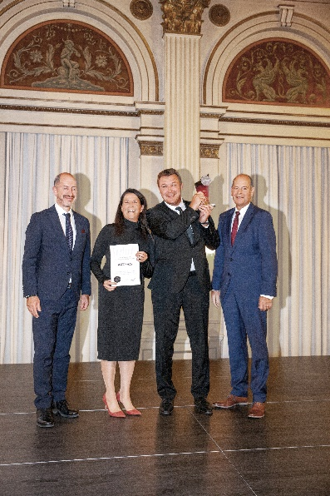 |  | Henning Schulz, Head of Corporate Communication, and Fátima Wille, Team Lead Marketing Germany, from STIEBEL ELTRON are delighted: the company has once again received the Superbrand Award. Norbert Lux on the right and András Wiszkidenszky on the left, who presented the awards.  Photo: fotostudio9, Marco Stirn

Picture 2
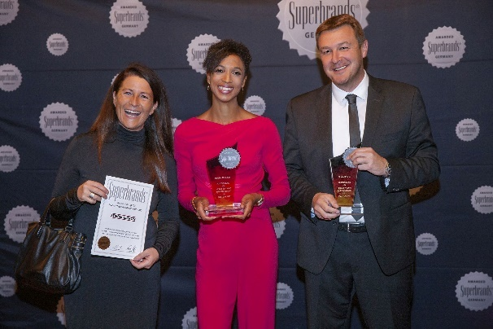 |  | The 2022 Superbrand personality, Olympic champion and multiple world champion in the long jump Malaika Mihambo, with Fátima Wille and Henning Schulz from STIEBEL ELTRON.  Photo: fotostudio9, Marco Stirn

