Product of the year for the houses of the year

Stiebel Eltron LWZ 8 CS integral unit wins award
In the category "Product of the Year - Heating and Ventilation", the Stiebel Eltron integral unit LWZ 8 CS was awarded the Callwey Award at the Houses of the Year ceremony. The LWZ 8 CS is particularly impressive due to its compact design: Air-to-water heat pump, ventilation and domestic hot water tank are efficiently combined here on only a little more than one square metre of installation space.

In recent years, the LWZ integral unit from Stiebel Eltron has become the building technology darling of architects, builders and house manufacturers. "The award for Solution of the Year 2022 makes us very proud 23 years after the market launch of the very first LWZ - it shows how innovative the development of the unit was right from the start and how the technology has been optimized in recent years," explains Head of Corporate Communication Henning Schulz, who received the award at the ceremony in the German Museum of Architecture DAM Ostend in Frankfurt am Main. The LWZ fulfils all building services functions: heating, hot water, ventilation and, if desired, cooling. The all-in-one unit therefore forms the heart of a home and, thanks to its compact design, also saves valuable planning and installation time.

Award enters its twelfth round in 2022
The Product Solutions of the Year Award was embedded in the "Houses of the Year" award, which Callwey has been holding regularly for 12 years. This year, the jury had the challenging task of selecting the 50 most impressive houses from 140 submitted projects. The winners were selected by a jury consisting of the director of the Deutsches Architekturmuseum Peter Cachola Schmal, the managing director of the Informationszentrum Beton Ulrich Nolting, the editor-in-chief of BAUMEISTER Dr. Fabian Peters, the architectural historian, urbanist and author Dr. Turit Fröbe, the editor-in-chief of Atrium Roland Merz, the editor of werk, bauen + wohnen Jenny Keller, the architecture journalist Katharina Matzig and the previous year's award winners, Andreas Fuhrimann Gabrielle Hächler Architekten, represented by Gabrielle Hächler.
About STIEBEL ELTRON
STIEBEL ELTRON is an internationally operating Group and is among the global market and technology leaders in the fields of building services and renewable energies. Since 1924, technical performance, quality, innovation, reliability and customer-oriented service have been defining factors in our success. With four national and four international production facilities, 26 sales organisations around the world, plus partners and agencies in 120 countries, STIEBEL ELTRON has a global presence. The annual turnover amounts to more than 800 million Euros. More than 50 per cent of the turnover is generated abroad.
In 1924 in Berlin the company founder Dr Theodor Stiebel started realising his vision of developing and manufacturing products with low energy consumption, greater safety and more comfort. This objective still applies to the company today.

Picture 1:
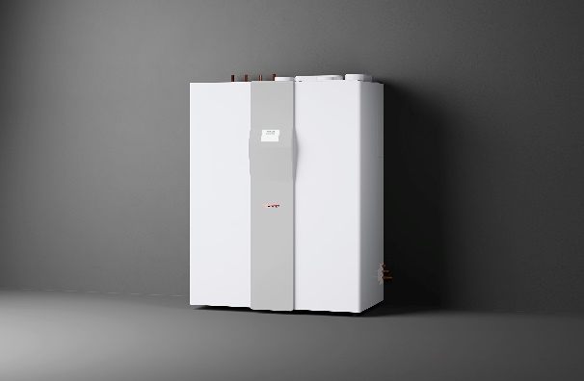 |  | The compact LWZ 8 CS integral unit from Stiebel Eltron wins the Callwey Award for Solution of the Year. It was not only the compact design that convinced the jury, but also the efficient technology.

Picture 2
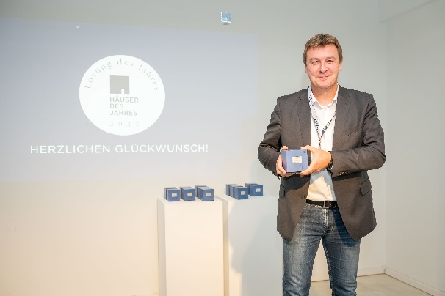 |  | Stiebel Eltron Head of Corporate Communications Henning Schulz is delighted to accept the "Solution of the Year" award for the LWZ integral unit.
If required, please contact the following person:
STIEBEL ELTRON:
Henning Schulz
Leiter Unternehmenskommunikation
Tel.: +49 (0) 55 31 / 70 29 56 85
henning.schulz@stiebel-eltron.de

