German Heat Pump Boom To Do Without Russian Gas: Stiebel Eltron Invests 600 Million Euros

400 new green tech jobs in Lower Saxony, Germany
Germany wants to become independent of Russian gas: Demand for environmentally friendly electricity-based heating is booming. By the end of the year, the German medium-sized company Stiebel Eltron expects to have produced a record 80,000 heat pumps - an increase of 60 percent compared to the previous year. For the near future, the company is planning further investments of more than 600 million euros. Production capacities will be expanded, research and development financed, and new jobs created.

"We have specialized in electricity-powered heat pump systems 'Made in Germany'. With experience of almost 50 years of in-house development work, we are among the technical market leaders," says Dr. Kai Schiefelbein, Managing Director of Stiebel Eltron. "Environmentally friendly heating technology does not require oil and gas and is therefore of outstanding importance both for climate protection and for Germany's energy supply security. We will continue to expand in this market."

Strong Demand
Demand for heat pump systems is huge: 154,000 units were installed in Germany in 2021 – these are 34,000 more than the year before. For the current year, an even greater leap to 250,000 heat pumps is now expected, and perhaps even the 300,000 mark could be reached. Naturally, this also has an impact on the manufacturers: Stiebel Eltron is aiming for another sales record this year - even revenues of 1 billion euros are possible.

New Jobs
The German government has set ambitious targets: from 2024, 500,000 heat pumps systems are to be installed in Germany every year. All participants in the recent heat pump summit with German economy minister Robert Habeck, and Federal Minister of Construction Klara Geywitz, also declared their support for this goal: "Together, we will create the conditions for the 500,000 heat pumps to be newly installed from 2024", says Dr. Kai Schiefelbein.
About STIEBEL ELTRON
STIEBEL ELTRON is an internationally operating Group and is among the global market and technology leaders in the fields of building services and renewable energies. Since 1924, technical performance, quality, innovation, reliability and customer-oriented service have been defining factors in our success. With four national and four international production facilities, 26 sales organisations around the world, plus partners and agencies in 120 countries, STIEBEL ELTRON has a global presence. The annual turnover amounts to more than 800 million Euros. More than 50 per cent of the turnover is generated abroad.
In 1924 in Berlin the company founder Dr Theodor Stiebel started realising his vision of developing and manufacturing products with low energy consumption, greater safety and more comfort. This objective still applies to the company today.

Picture 1:
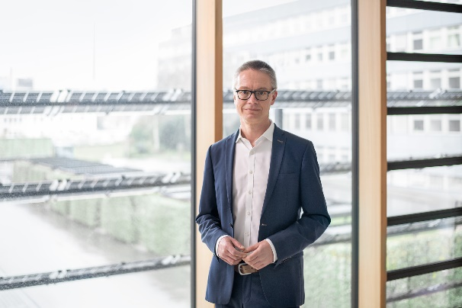 |  | Dr. Kai Schiefelbein, Managing Director of Stiebel Eltron
If required, please contact the following person:
STIEBEL ELTRON:
Henning Schulz
Leiter Unternehmenskommunikation
Tel.: +49 (0) 55 31 / 70 29 56 85
henning.schulz@stiebel-eltron.de

