STIEBEL ELTRON is Borussia Dortmund's new premium partner
Raising awareness, communicating sustainability
Heating manufacturer STIEBEL ELTRON is the new premium partner of Bundesliga soccer team Borussia Dortmund. "The focus of this partnership is, of course, to increase our brand awareness. However, we are also particularly enthusiastic about the concept of the sustainability partnership. As a heating expert, we can contribute our know-how and thus support BVB on its way to a CO²-free future," explains Managing Director Dr. Nicholas Matten. A very successful cooperation between STIEBEL ELTRON and BVB in Thailand and China has already existed for several years. Now the commitment is being extended to the German-speaking region.

The cooperation is set to run for three years. In addition to the classic perimeter advertising at BVB's Bundesliga home games, the sponsoring package includes numerous other marketing measures. For the globally successful heat pump manufacturer, however, the commitment is not only fitting in view of BVB's outstanding name recognition: "We are not only a premium partner, but also a sustainability partner of Borussia Dortmund," explains Nick Matten. "We will fill this partnership with life. There are already initial concepts on how BVB's various properties can be decarbonised in terms of heat supply with the help of heat pumps as heating systems."

"We are very pleased about the expansion of the partnership with STIEBEL ELTRON," said BVB Managing Director Carsten Cramer. "The topic of sustainability plays a major role for us. We are aware of our social responsibility and are already very active in many areas. There is actually still a need to catch up in the area of energy, especially in terms of decarbonisation and thus CO2 savings. With STIEBEL ELTRON we have a partner with whom we can also tackle this task."
About STIEBEL ELTRON
STIEBEL ELTRON is an internationally operating Group and is among the global market and technology leaders in the fields of building services and renewable energies. Since 1924, technical performance, quality, innovation, reliability and customer-oriented service have been defining factors in our success. With four national and four international production facilities, 26 sales organisations around the world, plus partners and agencies in 120 countries, STIEBEL ELTRON has a global presence. The annual turnover amounts to more than 800 million Euros. More than 50 per cent of the turnover is generated abroad.
In 1924 in Berlin the company founder Dr Theodor Stiebel started realising his vision of developing and manufacturing products with low energy consumption, greater safety and more comfort. This objective still applies to the company today.

Bild 1:
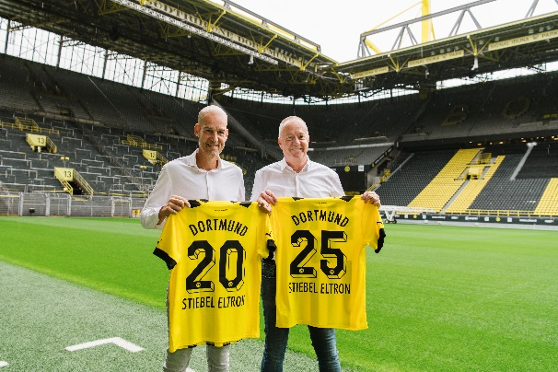 |  | Caption:  Spectacular new signing: heating manufacturer STIEBEL ELTRON is the new premium and sustainability partner of Bundesliga soccer club Borussia Dortmund. Managing directors Carsten Cramer (BVB, left) and Dr. Nicholas Matten (STIEBEL ELTRON) at the official announcement.

Bild 2
Caption:
Good chemistry between BVB and STIEBEL ELTRON - positive mood among Carsten Cramer and Nicholas Matten as well as Benedikt Scholz (right), Director of Internationalisation & Commercial Partnerships at Borussia Dortmund.

Bild 3
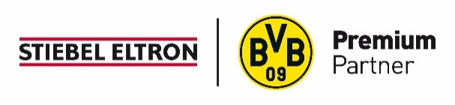 |  | Caption:  STIEBEL ELTRON is now a Premium Partner of Borussia Dortmund.

