Technical college draws first conclusions about new ventilation units
"Extremely quiet and reliably good air quality"
Six classrooms at a technical college in Holzminden were equipped with decentralised VRL-C ventilation units from local manufacturer Stiebel Eltron during the 2021 summer holidays. Now school headmaster Andreas Hölzchen drew a first conclusion: "The units are extremely quiet and reliably ensure good air quality - so the experience so far has been absolutely positive!"
Every 20 minutes, the headmaster's voice sounds over the school's public announcement system: "Please ventilate!" The reminder is actually hardly necessary; since the beginning of the Corona pandemic, teachers and students alike have internalised the air exchange necessary to minimise the risk of infection. "The announcement is there to ensure that the windows are opened regularly - some people forget to open them at the right time," says Hölzchen. Now the announcement would have to be extended, the headmaster also knows: "We should actually announce: Please ventilate - except in the classrooms where ventilation units are installed." Because controlled ventilation with the VRL-C from Stiebel Eltron ensures good air quality more reliably and permanently than opening the windows. The CO2 concentration in the room is used as a guide variable for the operation of a unit: it is measured and the ventilation intensity is regulated depending on the load.
Peter Koß, ventilation expert of the Stiebel Eltron Group: "A high CO2 concentration, which leads to tiredness and headaches, can only be reduced by supplying fresh air. That's why the CO2 concentration is the guiding variable, for the strength of ventilation." With the Corona pandemic, another advantage of ventilation came to the fore: "Not only does the CO2 concentration drop, but the aerosols are also removed to the outside. The aerosol concentration is kept constantly low, which massively reduces the risk of infection."
Minimal installation effort
The installation of the units was carried out by the company Gebrüder Becker. Seven units were installed in just a few days. Five of the six classrooms were equipped with a VRL-C 870 G Trend. In this size, the ventilation unit can achieve up to 4 air changes per hour in the respective rooms. The planners opted for a combination of two VRL-C 625 G Trend units in the largest of the six classrooms.
The VRL-C series is especially suitable for retrofitting corresponding rooms. "The units are installed under the ceiling to save space. We exchanged a window pane with a panel with corresponding cut-outs for the supply and return air," confirms Peter Koß. Thanks to the integrated heat recovery of the ventilation units, no adjustment of the heating is necessary: "The rooms continue to be pleasantly warm as usual."
The feedback from pupils and teachers has been extremely positive so far, according to headmaster Hölzchen: "One concern was that the noise from the ventilation would be disturbing. That has turned out to be completely unfounded: The operation of the devices is hardly noticed, there are rather questions about when the device will finally be put into operation - although it has already been running for a long time." Mark Becker from the installation company Gebrüder Becker supports this statement: "We have meanwhile installed numerous devices of this kind in various schools. Complaints about disturbing noises are almost non-existent."
Also suitable for offices, restaurants, waiting rooms or other larger rooms
The fresher the air, the lower the risk of infection. That's why the VRL-C is also perfect for retrofitting in other public or commercial spaces. No one has to worry about regular ventilation; even on cold days, hardly any heat energy is lost. For this reason, controlled ventilation has long been standard in new commercial buildings.

Mark Becker from the installation company Gebrüder Becker explains the functions of the unit's control system to school headmaster Andreas Hölzchen.
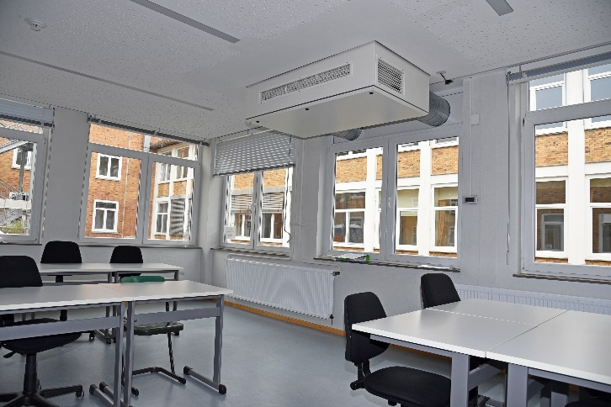
Thanks to the ventilation unit, the pupils can concentrate and study without disruption - without having to interrupt lessons every 20 minutes to open the windows.

