European Environmental Bureau EBB: Consumer survey gives good marks to heating heat pumps
EBB consumer survey in 22 European countries
88 percent of European consumers are satisfied with their switch to climate-friendly heating systems. Heat pumps and solar technology convince consumers both financially and ecologically. These are the findings of the European Environmental Bureau (EEB), which surveyed 710 participants in the European Union, Norway and the United Kingdom as part of the NGO campaign "Coolproducts".
"The results of the consumer survey impressively show that heat pump technology can be used as a reliable alternative to climate-damaging natural gas and oil burners," says Dr. Nicholas Matten, Managing Director of Stiebel Eltron, manufacturer of environmentally friendly home and system technology.
Environmentally friendly heating with heat pumps
Heat pumps extract environmental energy from the ambient air, the ground or groundwater and make it usable as heating energy. Electricity is needed to drive them. The systems can be coupled with solar power from the roof and are suitable for both new buildings and renovations.
About the Coolproducts study of the European Environmental Bureau (EEB)
Further information on the consumer survey "The Comfort Zone - European users' perception of renewable heatig performance" and the study can be downloaded here: https://ots.de/4qyfSX#

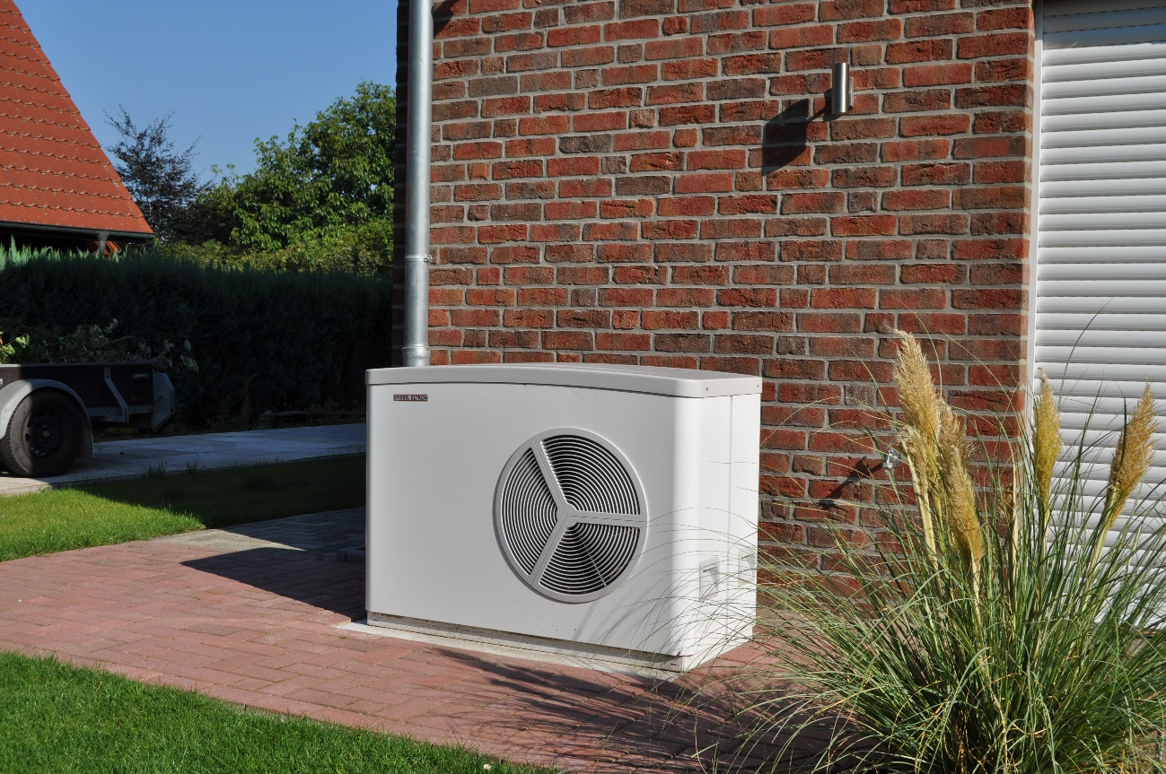
Positive feedback for heat pumps in Europe according to a survey by the European Environmental Bureau EBB.

