European Environmental Bureau: Stiebel Eltron is a "Climate Leader”
19 companies lead Europe’s heating sector out of fossil gas
Stiebel Eltron is one of the "Climate Leaders" in the European heating industry. Companies in this top category lead the way with their portfolio in the use of climate-friendly renewable energies. This is the result of a current market analysis by the European Environmental Bureau EEB.
"The European Environmental Bureau awards the top rating 'Climate Leader' to both our brand 'Stiebel Eltron' and our 'Thermia' appliances - we are very pleased with this excellent result for our climate-friendly portfolio", says Dr. Nicholas Matten, Managing Director of Stiebel Eltron, manufacturer of climate-friendly heating technology.
Climate targets achievable with heat pumps
With heat pumps, countries in Europe have the technology they need to achieve their climate protection goals: By 2030, the EU Commission wants to save 55 percent of greenhouse gases compared to 1990. To achieve this, emission levels in the building sector are to be drastically reduced. So far, 36 percent of the damaging emissions in the European Union are caused by the building sector.
Calling on governments - a climate-friendly turnaround in heating
In order to decisively advance the climate-friendly turnaround in the heating sector, the 19 Climate Leaders, together with the European Environmental Bureau, are sending an appeal to their respective governments: https://eeb.org/19-companies-lead-europes-heating-sector-out-of-fossil-gas-joint-ngo-industry-press-release/.
About the European Environmental Bureau (EEB) Brand Audit
The European Environmental Bureau (EEB) conducted a brand audit of European heating manufacturers on behalf of the NGO Coolproducts campaign. The heating companies were rated on the climate friendliness of their portfolio. The top rating in the category "Climate Leaders" was achieved by a total of 19 companies out of a total of 49 surveyed.

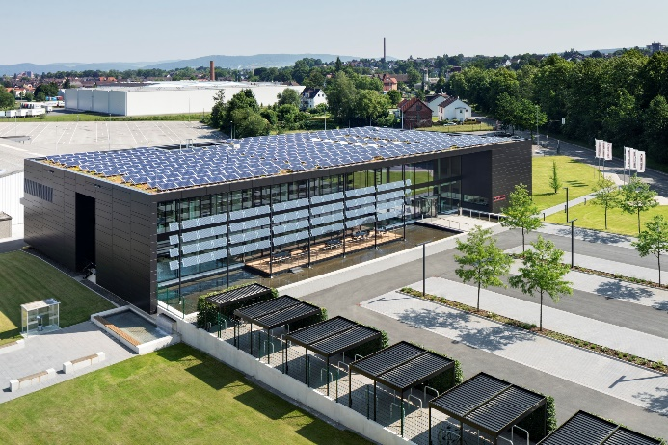
According to the European Environmental Bureau, Stiebel Eltron is a "Climate Leader" among European heating manufacturers.
