"GreenTech" Boom in Germany: Stiebel Eltron reports double digit growth
Outlook: 400 new jobs by 2026
GreenTech is boosting the economy in the German SME sector: Stiebel Eltron, has significantly increased its turnover in recent years to 700 million euros. Last year alone, sales surged 18 percent compared to the previous year (2019-2020). In the current financial year, this mark will once again be exceeded. The most important driver is the business with environmentally friendly heat pump systems "Made in Germany".
"In the last five years, our turnover from the sale of heat pumps has more than tripled," says Nicholas Matten, one of StiebeI Eltron's two managing directors. "By 2026, we aim to double the production capacities at our headquarters in Holzminden, Germany. We will invest around 120 million euros in our heat pump production.”
400 new greentech jobs
The economic success with greentech also has a positive impact on employment: 400 new jobs are to be created in Holzminden by 2026 and qualification programs will be expanded: "The environmentally friendly technology offers excellent career opportunities for the entire heating industry in Germany," says Human Resources Manager Christiane Schäfer. "Our heat pump systems help to fight climate change so that we create jobs for a market of the future."
500,000 new heat pumps per year
The forecasts are extremely positive: in order to achieve the climate targets, Germany must quickly push ahead and install at least 500,000 new alternative heating systems every year - according to the calculation of experts. German consumers can take advantage of generous subsidies for switching from old oil and gas heating systems to heat pump systems.

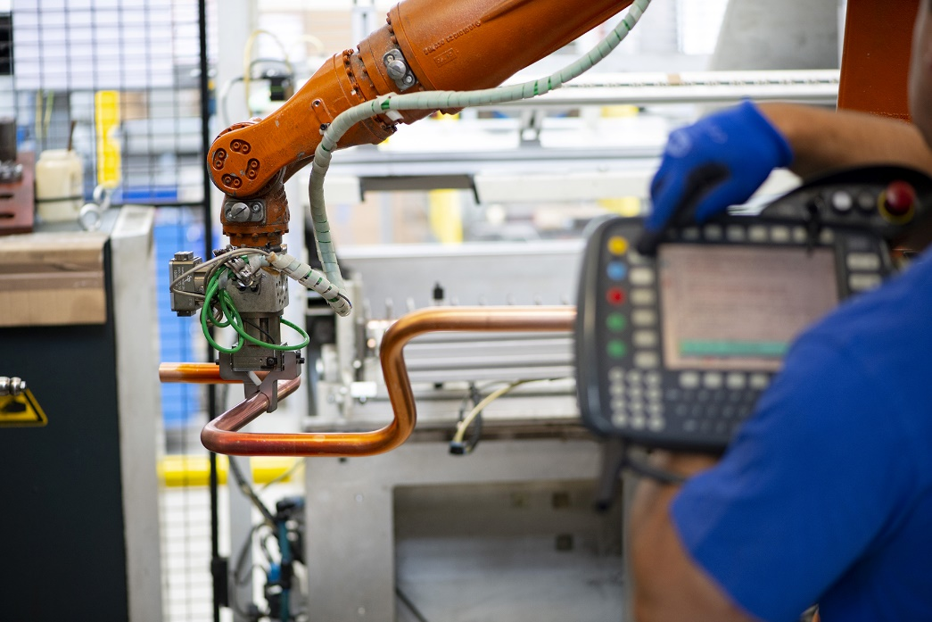
Green Tech Boom in Germany: STIEBEL ELTRON will invest will invest around 120 million euros in the heat pump production.

