Awarded: The STIEBEL ELTRON Brand
German Brand Award 2021
With the German Brand Award in the category 'Excellent Brand' Heating & Bathroom as well as a 'Special Mention' in the category Excellent Brands - Corporate Brand of the Year, the German domestic technology manufacturer Stiebel Eltron has now been honoured for its outstanding brand work. "This is great feedback for our work," says Claus Kroll-Schlüter, Director Group Marketing Stiebel Eltron, " Considering our brand evolution, which we have realised step by step over the last few months, this is a confirmation of the intensive sharpening of our brand image."
As a premium manufacturer of technology products for building services and green tech, Stiebel Eltron benefits from a strong brand profile. For almost 100 years, the German high-tech company has stood for home comfort, innovation and performance. Product highlights include environmentally friendly heat pumps and efficient ventilation units that ensure comfort.
German Brand Award': The Award for Successful Brand Management
Initiated by Germany’s design and brand authority, judged by a top-class panel of experts from brand management and brand science: the German Brand Awards are the award for successful brand management in Germany. The awards discover, present and award unique brands and brand builders.
In 2021, the German Brand Awards were able to achieve a great international response with 1134 submissions from 17 countries. The jury is made up of independent, interdisciplinary experts from companies, science,
consulting, services and agencies. The submissions are evaluated according to the criteria of independence and brand typology, brand distinctiveness, differentiation from the competition and target group relevance. Brand management should take into account aspects such as sustainability, degree of innovation, continuity and future viability. Factors such as the design quality of the brand presence, the homogeneity of the brand experience and the economic success also play a decisive role in the adjudication process.
The German Brand Institute Foundation was established jointly by the German Design Council and GMK Markenberatung. The German Brand Awards let the foundation present a unique award for outstanding brand management.

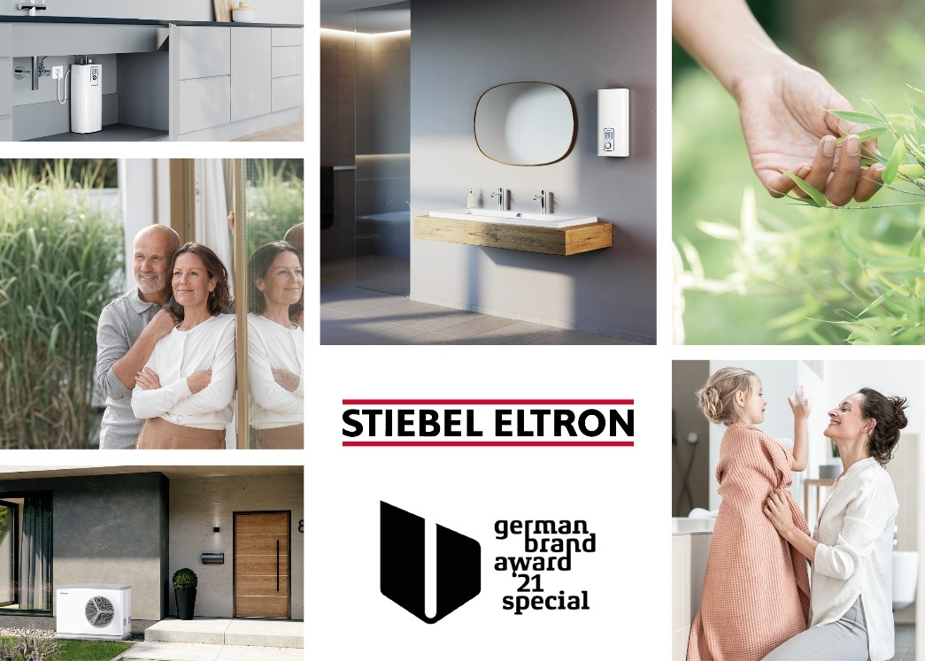
Stiebel Eltron is awarded the German Brand Award 2021 in the category 'Excellent Brand' Heating & Bathroom as well as a 'Special Mention' in the category Excellent Brands - Corporate Brand of the Year.

