Cooperation between Borussia Dortmund and STIEBEL ELTRON in China
Regional partnership of two strong brands
After the successful two-year partnership in Thailand, Borussia Dortmund and STIEBEL ELTRON are now also cooperating in China. The enthusiasm for German soccer is huge in China. Borussia Dortmund is one of the best known and most popular soccer clubs, not only in Germany but also worldwide. Therefore, we are very pleased about this cooperation, with which we are certain to increase our brand awareness in the region once again", says Dr. Nicholas Matten, Managing Director of the building services manufacturer. Benjamin Wahl, Head of BVB's presence in China, adds: "We are proud to be working with STIEBEL ELTRON in China. In addition to the enormous potential for using our brands on social media and at fan events, we share the same values: passion, authenticity and sustainability. That's why BVB and STIEBEL ELTRON will also be working together on social projects in China.
With three German and four international production facilities (one of them in Tianjin, China), 26 sales companies worldwide as well as sales organizations and agencies in over 120 countries, STIEBEL ELTRON is globally positioned. "We have been represented in the Chinese market since 2004 - but the potential is still huge. Ventilation systems, for example, play an important role in many high-quality new buildings as well as in renovation projects," says Matten. Even more exciting is the development in the heat pump sector. "In China, the largest national heat pump market in the world has emerged in the past five years - and we are one of the world's technology leaders for heat pumps. So, it's a perfect fit to have BVB as a partner on our side, who is inspiring so many people in China. In Thailand, we have already been cooperating with BVB for two years and gained excellent experience throughout. Therefore, we are certain that the cooperation will be successful in China as well".
The focus of the collaboration will be in the digital field - especially for joint activities on social media. Perimeter advertising in the Chinese stream of selected BVB Bundesliga matches has also been agreed upon – this was already implemented in the latest game against Bayern Munich.
"We are convinced that the partnership with BVB will help to increase awareness of the STIEBEL ELTRON brand in China. In future, we will plan many exciting joint activities to reach even more people in China with our message: STIEBEL ELTRON, a German family-owned company with a 96-year history, enables the highest level of living comfort - thanks the innovative electric-powered solutions for heating, cooling, hot water and ventilation," says Shen Chao, Deputy General Director of STIEBEL ELTRON China.

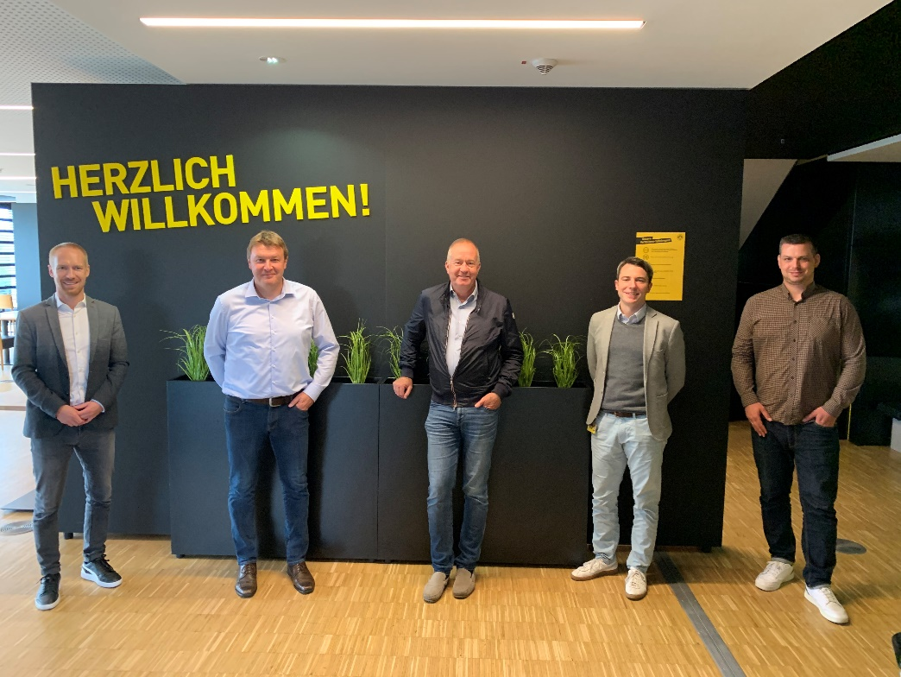
Looking forward to the collaboration in China (from left): Benedikt Scholz, Head of International BVB, Head of Public Relations Henning Schulz and Managing Director Dr. Nicholas Matten of STIEBEL ELTRON, Jonathan Webster of BVB agency SportFive and Daniel Lörcher, Head of Corporate Responsibility at BVB.

