UNO acknowledges Stiebel Eltron's commitment to climate protection
Holzminden, 12.05.2020 - The United Nations have thanked Stiebel Eltron for its commitment to climate protection. Background: Together with 67 companies from all sectors of the economy, the German manufacturer of environmentally friendly home and systems technology launched the largest climate policy appeal for companies in Germany to date. Stiebel Managing Director, Dr. Nicholas Matten, signed the appeal "For crisis management and sustainability: Making our economy more crisis-proof with a climate economic stimulus programme".
In the thank-you letter from the United Nations, the Executive Secretary of the UN Climate Secretariat (UNFCCC), Patricia Espinosa, acknowledges the purposeful and rightful request to the government to systematically link economic measures to solve the corona crisis with ambitious climate protection goals.
Why we cannot afford to make bad investments
"We are pleased that the joint company appeal initiated by the "Stiftung 2 Grad" has met with a great response and are proud to contribute our share" says Dr. Matten from Stiebel Eltron.
"If we now lose sight of the climate targets and the measures necessary to achieve them, we will slide into the next global crisis: global warming. That is why we cannot afford to make bad investments in this critical phase. Rather, the financial resources for the new start must be used simultaneously for more climate protection in industry, transport and buildings. In addition, the measures from the climate package that have already been decided upon must be consistently implemented - such as switching to environmentally friendly heating technology."
Appeal sent to the Federal Government
The appeal, supported by medium-sized German companies and DAX-listed corporations, was sent to the German government at the start of the Petersberg Climate Dialogue and made an important contribution to the summit. Sabine Nallinger, chairwoman of the 2 Grad Foundation, also addressed a personal letter to Dr. Matten and thanked him for "an important sign of ambitious climate protection in economically challenging times".
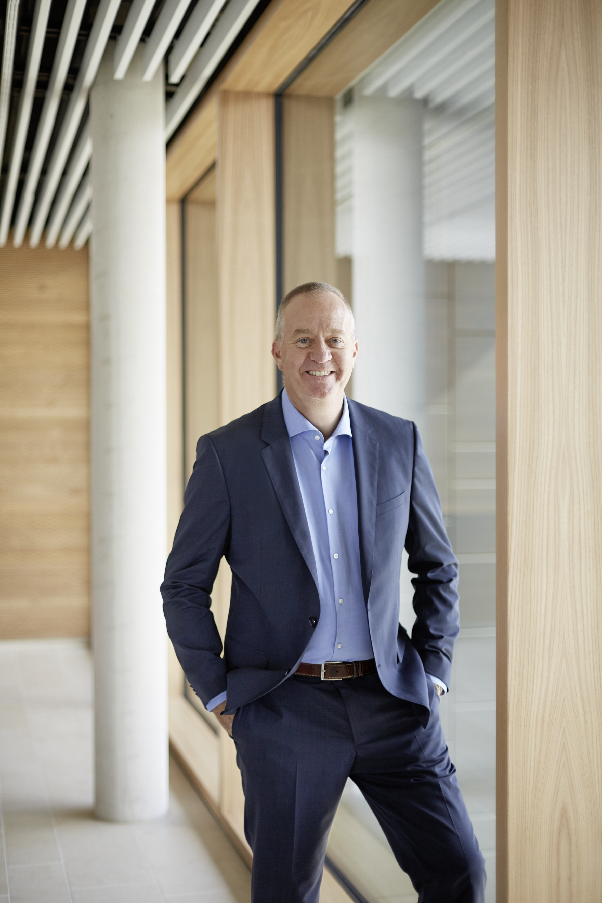
Dr. Nicholas Matten, Managing Director Stiebel Eltron Group

