Lovie Award for Online Campaign by STIEBEL ELTRON
Many likes from all over Europe for feel-good campaign
The home technology manufacturer STIEBEL ELTRON has won the "Lovie" audience award for its current online campaign on the subject of feeling comfortable at home. From 1,500 submitted projects from 33 countries, the company was able to stand out with the new campaign and inspire the users.
In the award-winning online campaign, STIEBEL ELTRON demonstrates that warmth and well-being are determined in particular by the right building technology. To create a warm, comfortable home is the focus of the campaign. Since September, homeowners and those who still want to become homeowners have increasingly come across the campaign of the traditional German company. The focus is on selecting the right home technology – based on renewables. The campaign messages are presented via a short, emotional video that is distributed via the company's online channels - including YouTube, Facebook and Twitter. The campaign is accompanied by online ads and other communication measures. "For decades, our claim has been 'Comfort through Technology' - and that's exactly what it's all about," says Marketing Director Claus Kroll-Schlüter, "feeling comfortable at home. The good feeling of having relied on the right building technology plays a key role here".
The award is already being presented in its tenth year to the designers of the European Internet landscape, including bloggers, creative campaigns and websites. The awards honour projects in the five main categories: website, apps/mobile sites/podcasts & voice, internet video, online advertising and social.
To the campaign: www.stiebel-eltron.com/en/home/company/magazine/home-is-comfort.html

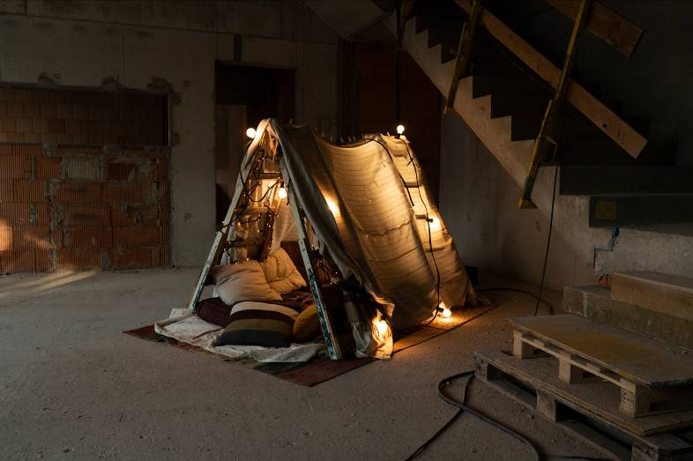
The online campaign by STIEBEL ELTRON on the subject of "Feeling good at home" wins the audience award "Lovie-Award".

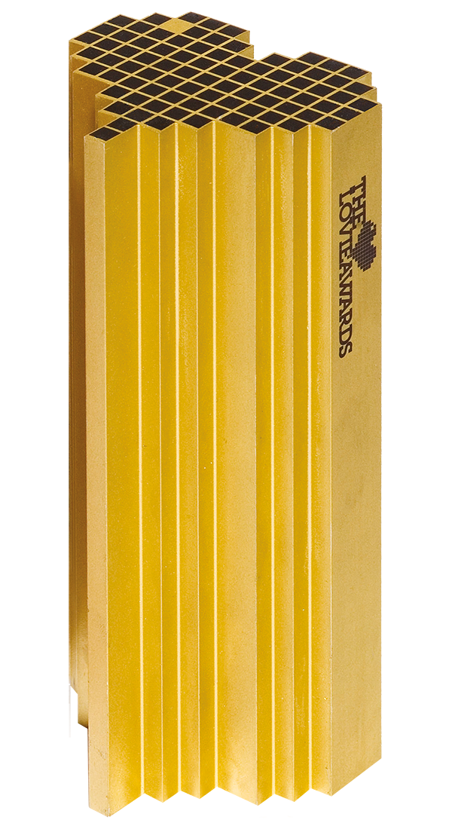

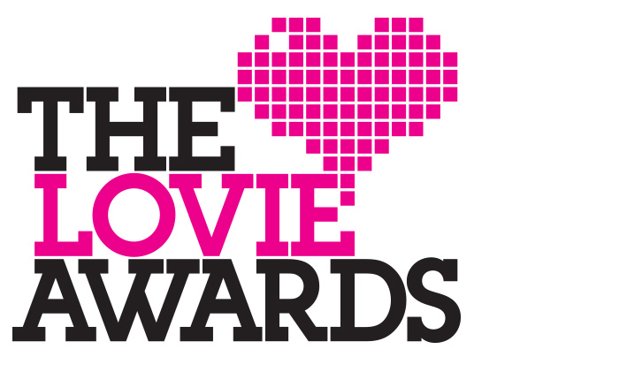
The Lovie Awards have been presented to the designers of the European Internet landscape for ten years.

