DCE Series instantaneous water heaters from Stiebel Eltron
The ideal DHW solution for any need
With the DCE series, the German hot water and heating technology expert Stiebel Eltron offers a powerful, space-saving compact electric instantaneous water heater for various hot water requirements. Proven technology meets modern design.
The water heater is available in three versions: the DCE-X Premium with 4i technology and LC display and the 3i technology controlled DCE-S Plus with stepless temperature selection between 20 and 60 degrees as well as the DCE-C Trend with 2i technology for basic hot water applications. The rated output of the three versions can be set to 6, 8, 10 or 12 kilowatts. Profi Rapid installation technology allows particularly simple installation of the units.
The DCE-X Premium offers hot water comfort at the highest level. Thanks to 4i technology, all important parameters are permanently monitored so that a constant hot water temperature is guaranteed. In 0.5 degree intervals, the temperature can be set between 20 and 60 degrees on the LC display using a rotary selector. The display also shows the current electricity and water consumption. With three additional keys, two temperatures can be memorised and the Eco mode activated.
The DCE-S Plus electric instantaneous water heater is the economical power pack for hot water. The Plus version of the series also allows the user to set the preferred temperature continuously. The DCE-C Trend offers a more economical version of the series with fewer features: with 2i technology, it guarantees good energy efficiency and ensures a constant temperature of 55 degrees.

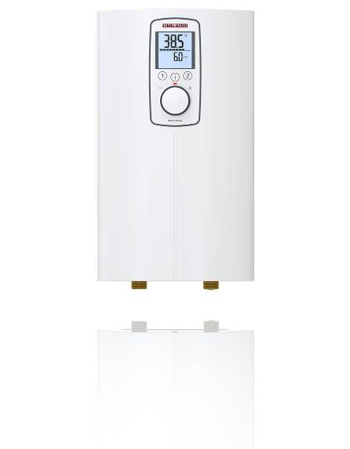
DCE-X Premium compact instantaneous water heater with 4i technology

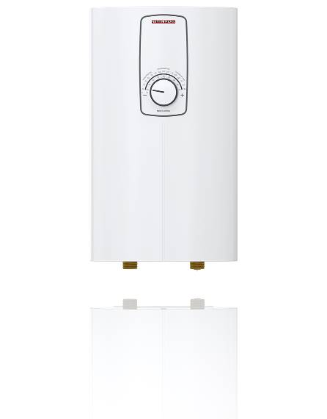
DCE-S Plus compact instantaneous water heater – economical power pack.
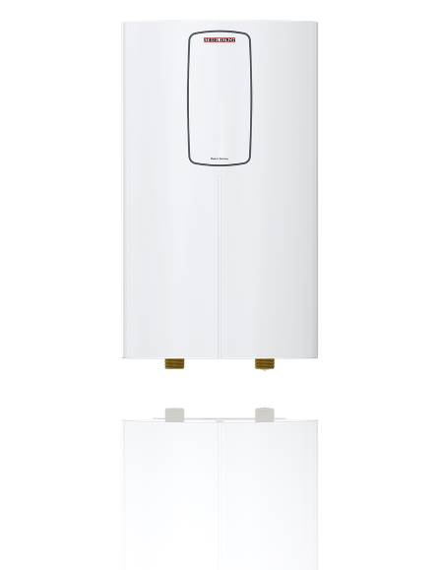
DCE-C Trend compact instantaneous water heater for basic hot water applications.

