Renovation with ventilation solutions from Stiebel Eltron
No pipework necessary
Whether in the bathroom, the kitchen or in the entire home - odours and moisture should be reliably transported to outside of the building, whereas fresh and, in best case, preheated air should be supplied to the interior. Stiebel Eltron offers the right solution for all requirements - for example with decentralised ventilation units that do not require pipework and are therefore particularly suitable for retrofitting in renovation projects.
LA 60 Plus - Single ventilation unit with humidity sensor
The LA 60 Plus ventilation unit from Stiebel Eltron is predestined for use in bathrooms, especially if the room does not have a window. Thanks to the integrated humidity sensor, an automatic, humidity-dependent volume flow control is carried out. The stale air is reliably discharged. Fresh air flows in via supply air elements provided in the living area. The LA 60 Plus is available as a wall-mounted or ceiling-mounted version, each as a surface-mounted or flush-mounted unit with a removable inner cover. Depending on the device version, it is available with or without fire protection.
VLR 70 - Ventilator with heat recovery
The devices are used at least in pairs and work alternately - so that there is no negative or positive pressure change in the room. Depending on requirements, up to eight ventilation units can be operated via one control unit and one operating unit. With regenerative heat transfer, the high-quality aluminium heat exchanger is charged with the thermal energy of the exhaust air. After 40 seconds, the EC fan changes direction and transports fresh air from the outside into the room. The previously absorbed heat energy is released into the incoming air. In this way, heating energy losses can be reduced by up to 93 percent.

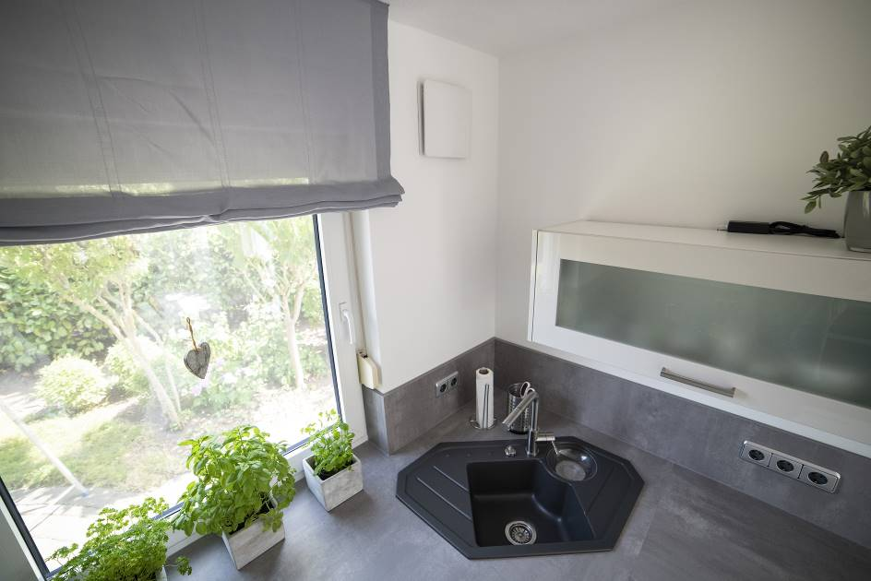
The LWE 40 fan from Stiebel Eltron reliably supplies the building with fresh air and recovers around 90 percent of the heat from the exhaust air.

